**DBMS LAB**

**ASSIGNMENT-7**

**SNEHA SINGH**

**20198023**

**IT 5 B2**

**1) Consider the following schema:**

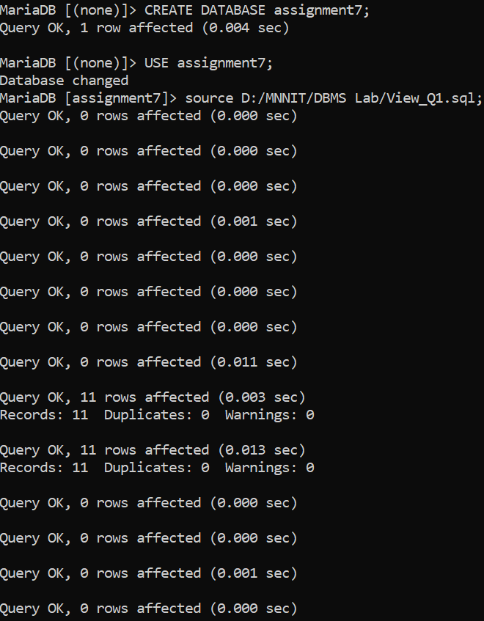

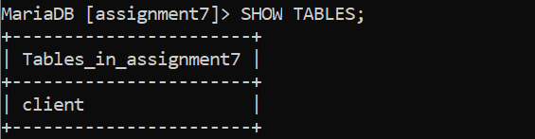

**a) Create a View called Client_View1 having all data of Client table.**

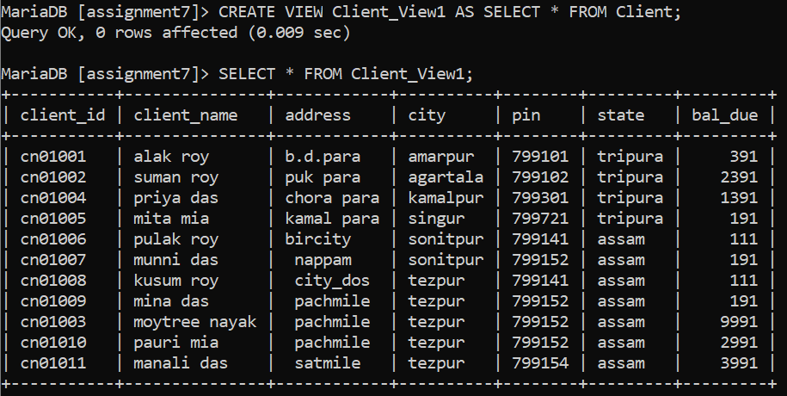

**b) Create a view called Client_vw2 having Client_ID, city and Bal_Due attributes of client table.**

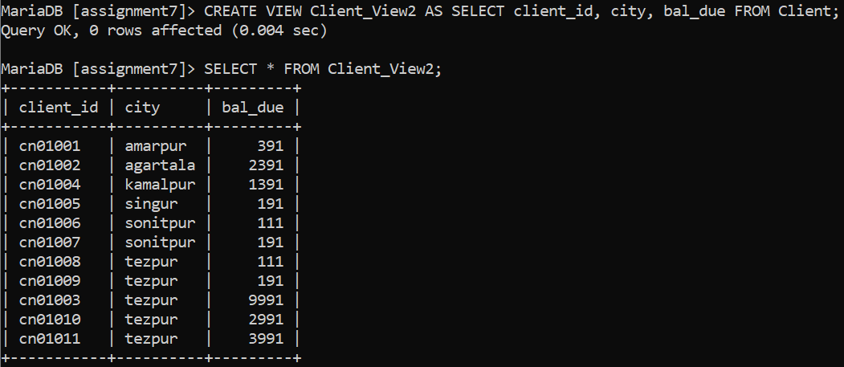

**c) Create a view called Client_vw3 with renaming Client_ID as CID, Client_Name as cname and Address as Addr of client table.**

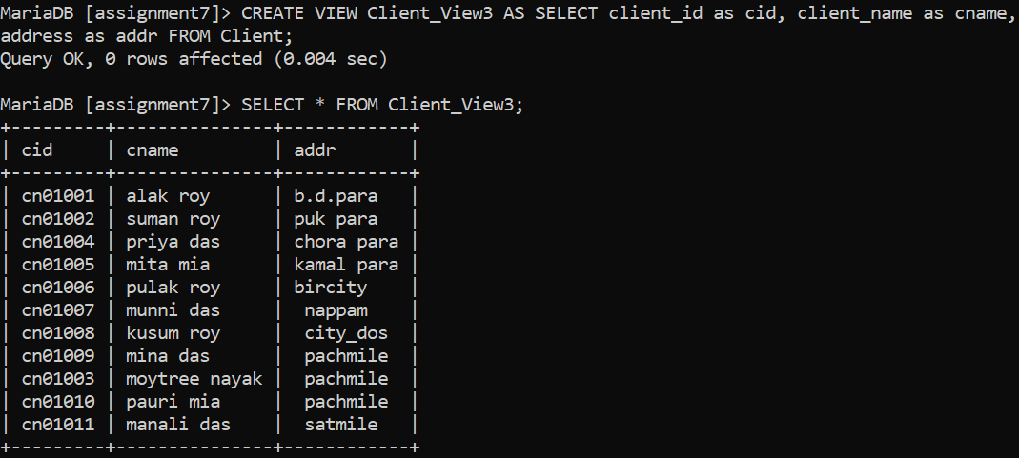

**d) Using Client_view1, print client_name and Balance of Client whose ID is ‘cn01001’.**

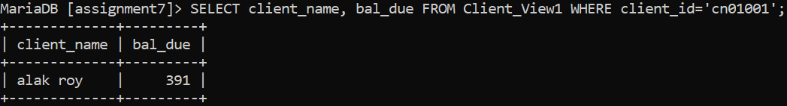

**e) Insert a row into Client_vw2 (‘cn02003’, ‘alld’, 5000).**

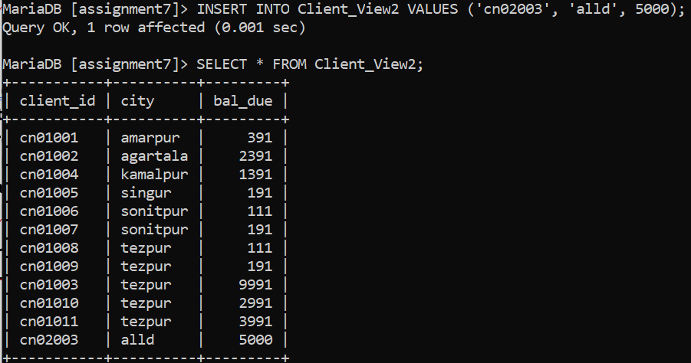

**f) Modify view Client_vw2 such that bal_due of Client_ID CN01004 now become 1000.**

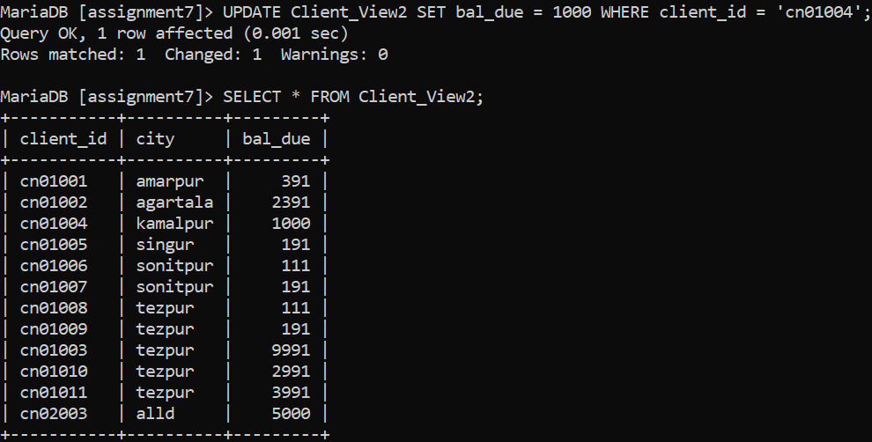

**g) Delete row from view client_vw2 where Client_ID=’CN02003’.**

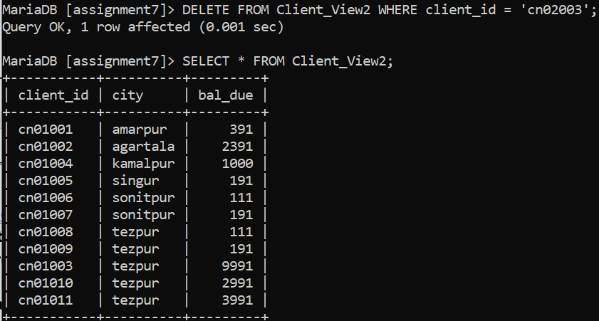

**h) Delete view client_vw3 from memory.**

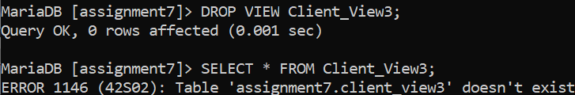

**i) Consider another table Client2 (ClientID, Phone). Create a view client_vw4 which has clientID, Client_name, bal_due and phone. Use both the tables Client and Client2.**

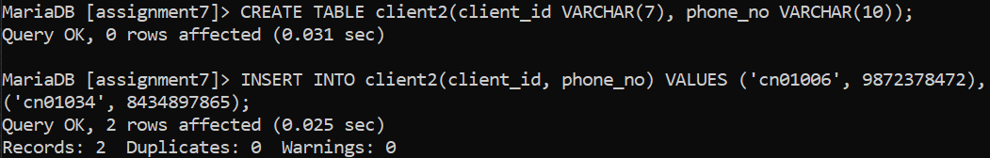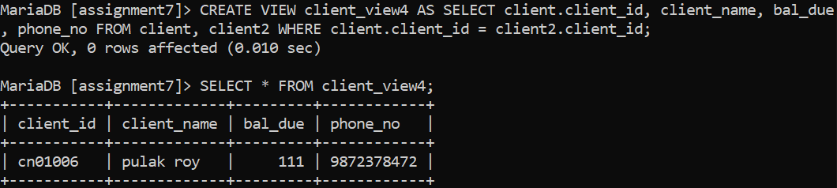

**2) Consider the following schema:**



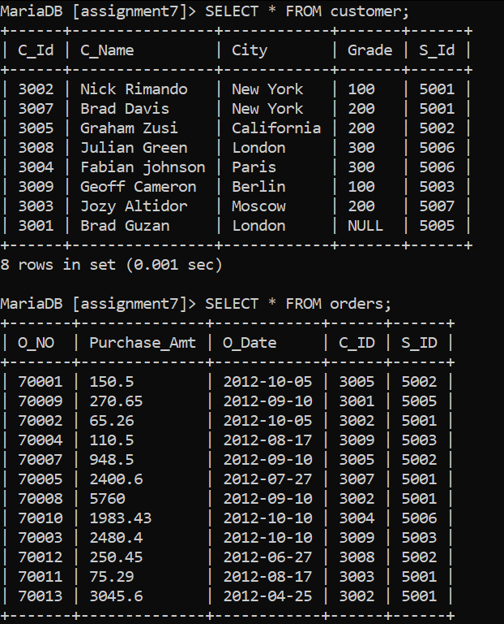



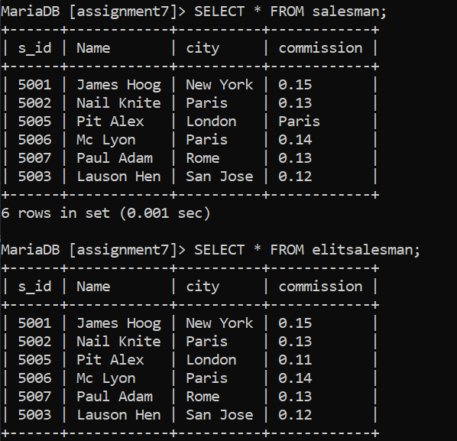

**a) Create a view for those salesmen who belong to the city ‘New York’.**

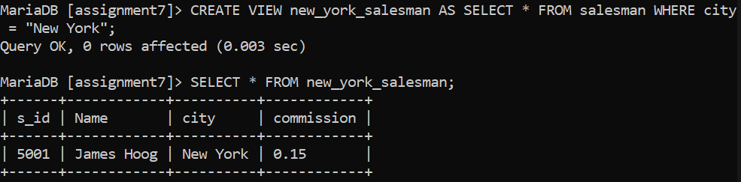

**b) Create a view for all salesmen with columns salesman_id, name and city.**

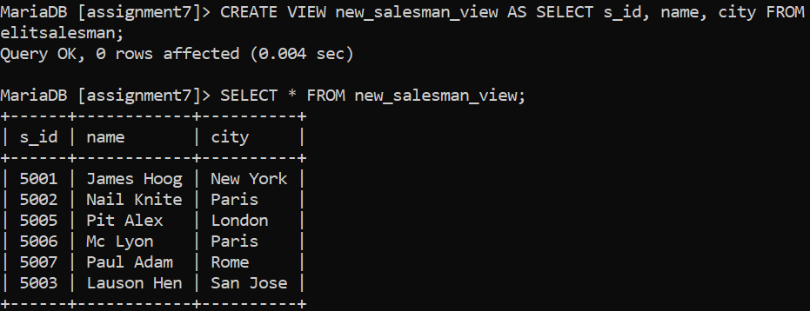

**c) Find the salesmen of the city New York who achieved the commission more than 13%.**

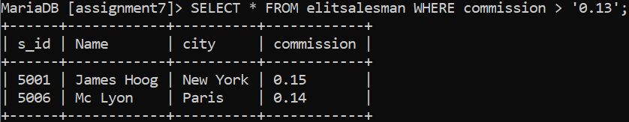

**d) Create a view to getting a count of how many customers we have at each level of a grade.**

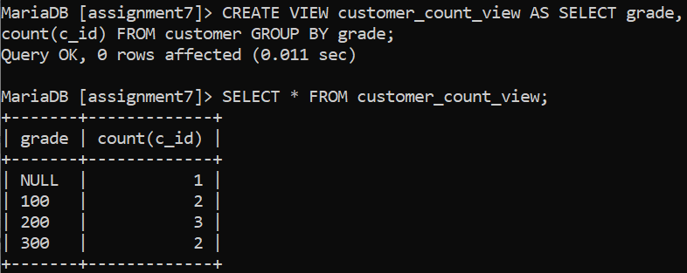

**e) Create a view to keeping track the number of customers ordering, number of salesmen attached, average amount of orders and the total amount of orders in a day.**

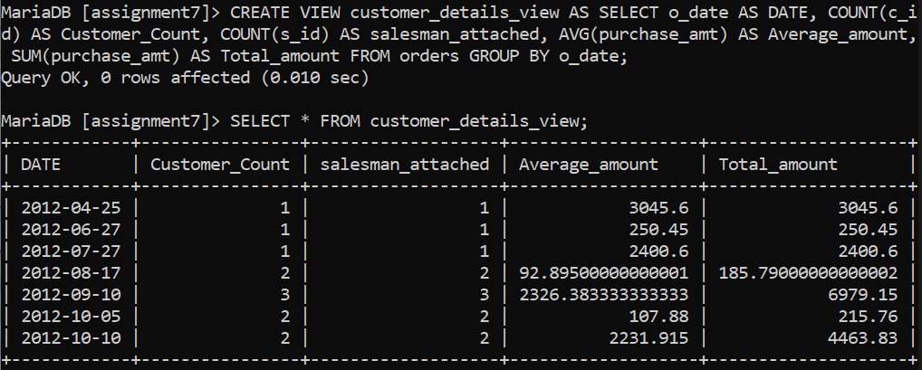

**f) Create a view that shows for each order the salesman and customer by name.**

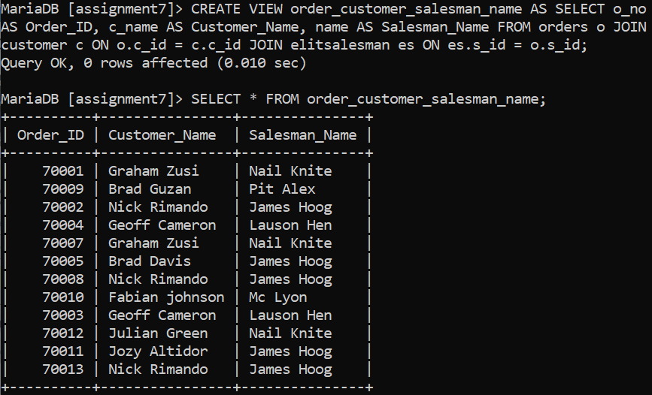

**g) Create a view that finds the salesman who has the customer with the highest order of a day.**

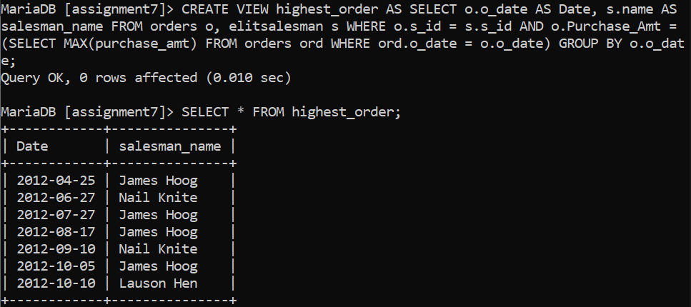

**h) Create a view that finds the salesman who has the customer with the highest order at least 3 times on a day.**

**i) Create a view that shows all of the customers who have the highest grade.**

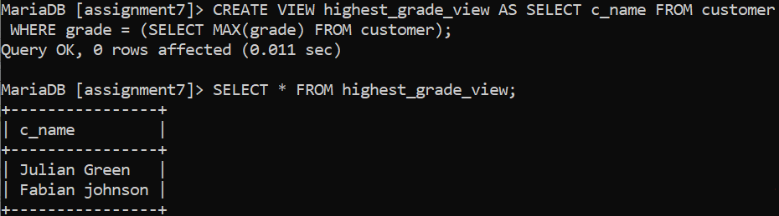

**j) Create a view that shows the number of the salesman in each city.**

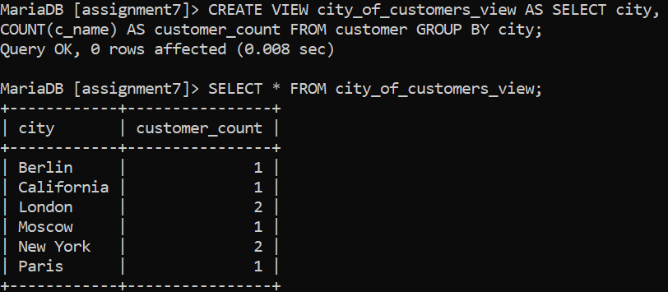

**k) Create a view that shows the average and total orders for each salesman after his or her name. (Assume all names are unique)**

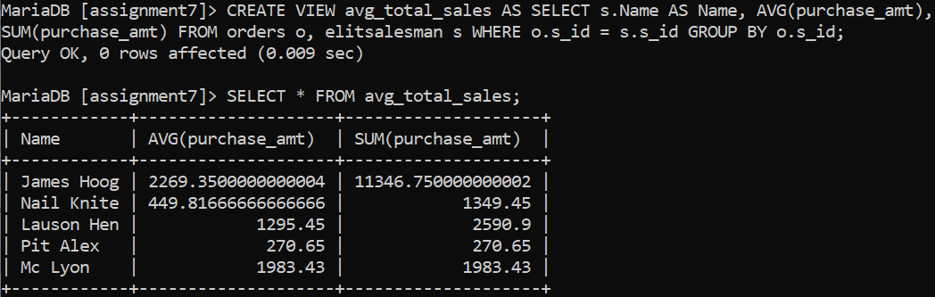

**l) Create a view that shows each salesman with more than one customer.**

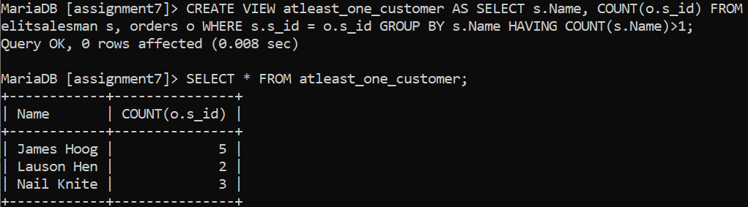

**m) Create a view that shows all matches of customers with salesman such that at least one customer in the city of customer served by a salesman in the city of the salesman.**

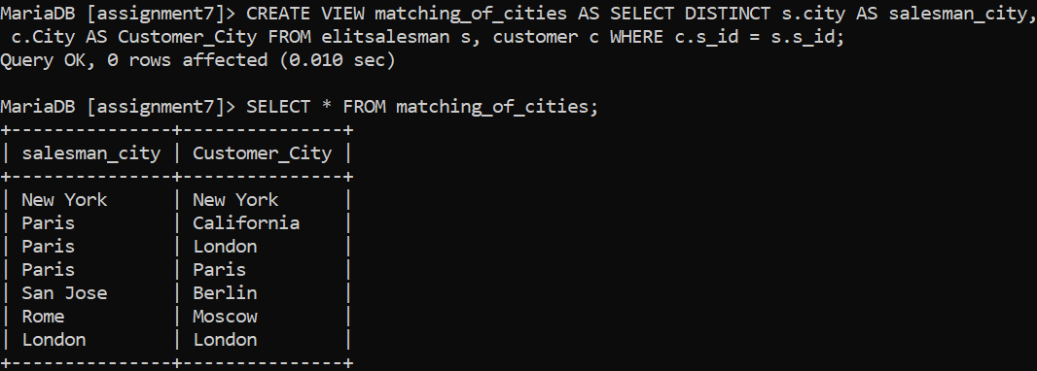

**n) Create a view that shows the number of orders in each day**

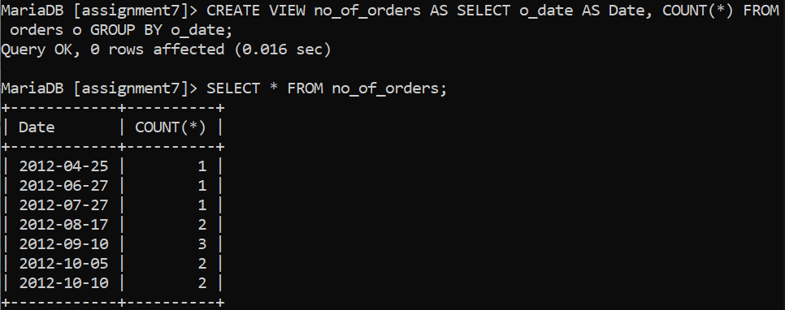

**o) Create a view that finds the salesmen who issued orders on October 10th, 2012.**

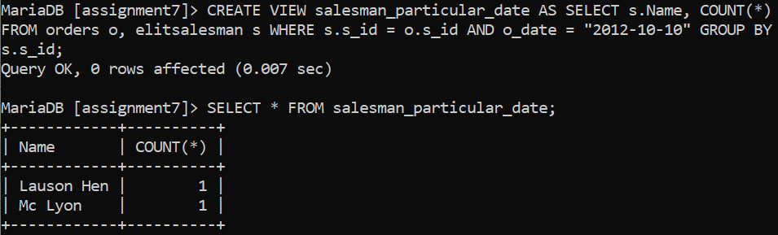

**p) Create a view that finds the salesmen who issued orders on either August 17th, 2012 or October 10th, 2012.**

